🏠 🔒 💡 🌡️ 🚨 🛜
ARDUINO BASED
SMART HOME
PROJECT DOCUMENTATION REPORT
— An Automated, Sensor-Driven Home Control System —
Designed & Simulated on Tinkercad
Microcontroller Platform: Arduino UNO
Project Submitted By
PILLA JOSHI
Door Lock | Light Control | Gas Detection | Locker Alarm | Fan Control

1. Introduction
This project implements a multi-function Smart Home Automation System using an Arduino UNO as the central controller. The system integrates five independent sensing and control modules — automatic door locking, ambient light control, gas leak detection, locker security monitoring, and temperature-based fan control — into a single circuit. All live readings and alerts are shown on a 16x2 LCD display and mirrored on the Arduino Serial Monitor, making the system easy to observe and debug during simulation.

2. Objective
- Automatically lock/unlock the main door based on the proximity of a person, using an ultrasonic distance sensor and a servo motor.
- Automatically switch the room light ON/OFF based on ambient brightness sensed by an LDR.
- Continuously monitor for gas leaks using an MQ gas sensor and trigger a buzzer + LCD warning when gas is detected.
- Detect unauthorized motion near a locker/cabinet using a PIR sensor and raise a security alarm.
- Monitor room temperature with a TMP36 sensor and regulate an exhaust fan's speed (PWM) accordingly.
- Display all live sensor data centrally on an I2C 16x2 LCD and on the Serial Monitor.

3. Components Used
Component | Reference | Function in Circuit
Arduino UNO | U1 | Main microcontroller; reads all sensors and drives all outputs
Ultrasonic Distance Sensor | DIST1 | Measures distance at the door to detect an approaching person
Micro Servo Motor | U3 (Servo) | Acts as the electronic door lock (locks / unlocks)
LDR (Light Dependent Resistor) | R2 / photoresistor | Detects ambient light level for automatic lighting
LED (White) | LED2 | Represents the room light, switched automatically
MQ Gas Sensor | GAS1 | Detects LPG / smoke / gas leakage
DC Motor | M1 | Represents the exhaust fan, speed-controlled by PWM
Diode | D1 | Flyback protection diode across the motor
PIR Motion Sensor | PIR1 | Detects motion near the locker/cabinet for security
Piezo Buzzer | U2 | Sounds audible alerts for gas leak and intrusion
TMP36 Temperature Sensor | U5 (SLHVD1) | Monitors room temperature to control the fan
16x2 I2C LCD Display | U4 | Displays live sensor readings and system status
Red Alarm LED | LED2 (bottom) | Visual alarm indicator
Resistors | R1, R3, R4 | Current-limiting resistors for LED/transistor circuits
NPN Transistor | Q1 | Switches the PIR/buzzer stage

4. Circuit Diagram
The schematic below (exported from Tinkercad) shows the complete wiring of the Smart Home system: the Arduino UNO (U1) at the centre, the ultrasonic distance sensor and servo for door control, the PIR sensor with buzzer for security, the gas sensor, the LDR/LED lighting branch, the TMP36 temperature sensor driving the DC motor (fan) through a transistor, and the I2C LCD used as the central status display.
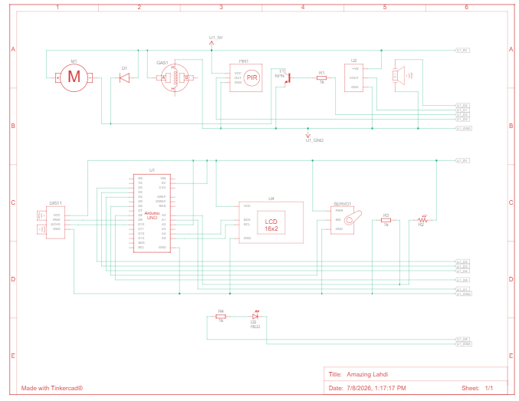
Figure 1: Complete circuit schematic — Arduino based Smart Home

4.1 Key Pin Connections
Signal | Arduino Pin | Purpose
trigPin | 9 | Ultrasonic sensor trigger (door distance)
echoPin | 10 | Ultrasonic sensor echo (door distance)
servoPin | 6 | Controls the door-lock servo motor
LDR (analog) | A-pin | Reads ambient light level
Gas sensor (analog) | A-pin | Reads MQ gas sensor value
TMP36 (analog) | A-pin | Reads temperature for fan PWM control
PIR (digital) | D-pin | Detects locker motion
Buzzer / LEDs | D-pin(s) | Drives audible and visual alarms
I2C (SDA/SCL) | A4 / A5 | Communicates with the 16x2 LCD (address 0x27)

5. Working Principle

5.1 Automatic Door Lock
The HC-SR04 ultrasonic sensor continuously measures the distance of any object/person approaching the door. When the measured distance falls below a preset threshold, the Arduino commands the servo motor to rotate to the "unlocked" position; otherwise the door remains "locked". The live distance and lock status are printed on both the LCD and the Serial Monitor.

5.2 Automatic Light Control
The LDR produces a varying analog voltage depending on the surrounding light intensity. The Arduino reads this value and switches the room LED ON when the surroundings are dark (low LDR value / low light) and OFF when it is bright, keeping the room lit automatically without manual switching.

5.3 Gas Leak Detection
The MQ gas sensor outputs an analog value proportional to the concentration of combustible gas/smoke in the air. When this value crosses the safety threshold, the system immediately flags a "GAS LEAK DETECTED" condition, sounds the buzzer in a repeating beep pattern, and displays the warning on the LCD so occupants can react quickly.

5.4 Locker Security (PIR Motion Sensing)
A PIR (Passive Infrared) sensor watches for motion near a protected locker or cabinet. Any detected motion is treated as a potential intrusion: the system logs "Locker Motion: DETECTED! ALARM", sounds the buzzer, and updates the LCD/Serial Monitor, providing a simple but effective security layer.

5.5 Temperature-Controlled Fan
The TMP36 analog temperature sensor reports the ambient temperature in °C. The Arduino maps this reading to a PWM value that drives the DC motor (representing an exhaust fan) — the higher the temperature, the faster the fan spins — helping regulate room comfort automatically.

5.6 Centralized Status Display
All five modules share one 16x2 I2C LCD (address 0x27). The display cycles through door status/distance, light status, temperature/fan PWM, gas status, and locker motion status, while the same information is streamed continuously to the Serial Monitor for logging and debugging.

6. Simulation Outputs
The following screenshots, captured from the Tinkercad simulation, demonstrate each module responding correctly to its sensor input, with the corresponding LCD display and Serial Monitor log shown alongside the circuit.

6.1 Door Unlocked Output
- Ultrasonic sensor measures a short distance (≈41–42 cm), which is within the unlock threshold.
- LCD reads "Door: UNLOCKED, Dist: 41 cm" and the servo drives the door mechanism open.
- Serial Monitor confirms Status: UNLOCKED alongside all other live sensor readings.
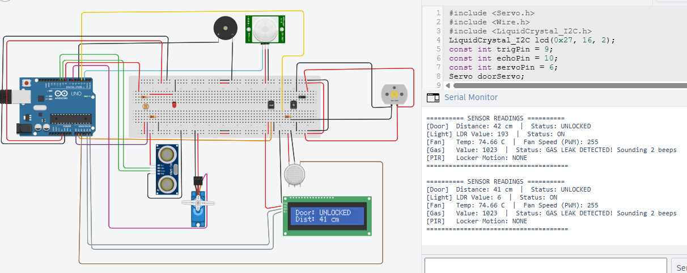

Figure: Serial monitor / simulation output — 6.1 Door Unlocked Output

6.2 Light ON Output
- LDR value reads 323 (low ambient light), so the lighting logic switches the LED ON.
- LCD displays "Light: ON, LDR Val: 323" confirming automatic activation.
- Serial Monitor log line [Light] LDR Value: 323 | Status: ON matches the LCD output.
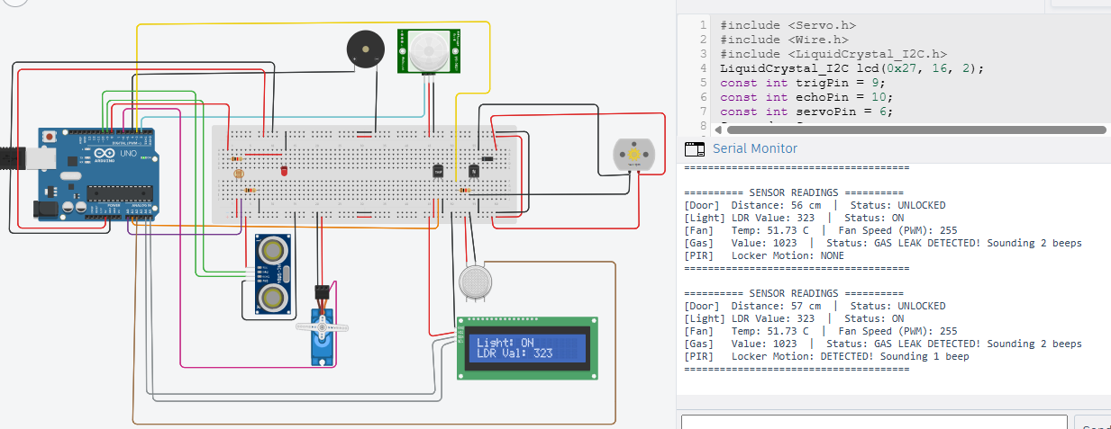
Figure: Serial monitor / simulation output — 6.2 Light ON Output

6.3 Gas Leak Detected Output
- Gas sensor value reaches the maximum reading (1023), well above the safe threshold.
- LCD immediately shows "Gas Value: 1023, LEAK DETECTED!" and the buzzer sounds 2 beeps.
- Serial Monitor logs Status: GAS LEAK DETECTED! Sounding 2 beeps for the operator/log record.
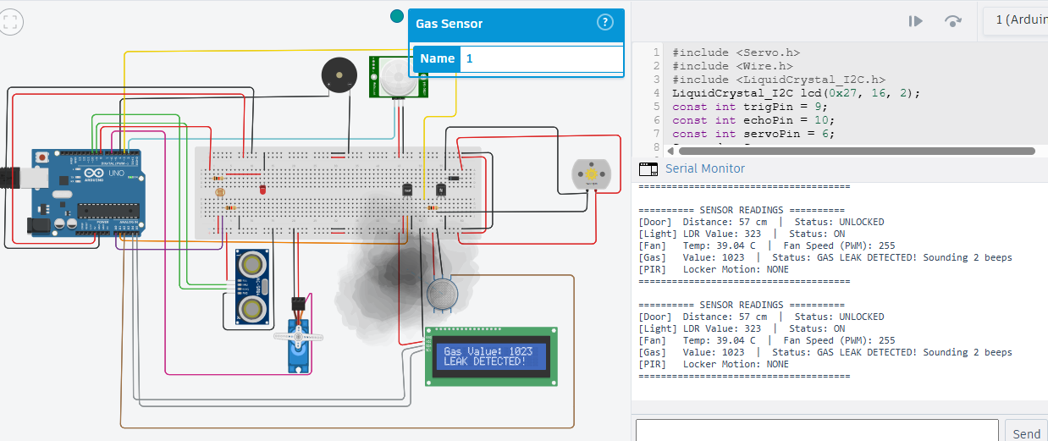
Figure: Serial monitor / simulation output — 6.3 Gas Leak Detected Output

6.4 Locker Motion Detected (Security Alarm) Output
- PIR sensor detects movement near the locker, changing status from NONE to DETECTED.
- LCD switches to "Locker Motion: DETECTED! ALARM" and the buzzer sounds 1 beep as an alert.
- Serial Monitor confirms [PIR] Locker Motion: DETECTED! Sounding 1 beep in the live log.
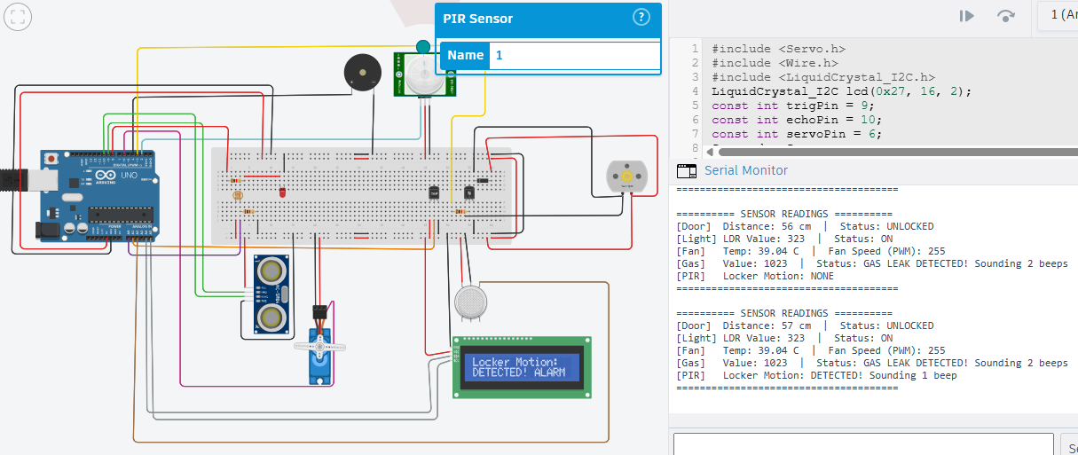
Figure: Serial monitor / simulation output — 6.4 Locker Motion Detected (Security Alarm) Output

6.5 Temperature & Fan Output
- TMP36 sensor reads a temperature of 39.04 °C in this simulation run.
- LCD displays "Temp: 39.04C, Fan PWM: 255", showing the fan running at full speed for the high temperature.
- Serial Monitor logs Temp: 39.04 C | Fan Speed (PWM): 255, confirming the automatic response.
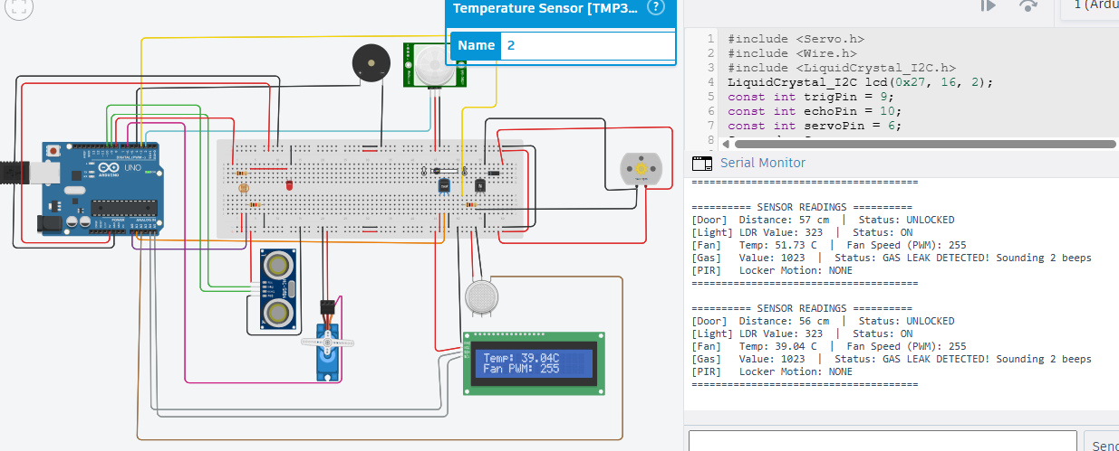
Figure: Serial monitor / simulation output — 6.5 Temperature & Fan Output

7. Conclusion
The Arduino based Smart Home system successfully demonstrates how a single microcontroller can coordinate multiple independent sensors and actuators to automate everyday home functions — secure entry, lighting, safety monitoring, and climate control. The simulation results confirm that each module (door lock, light control, gas detection, locker security, and temperature-based fan control) responds correctly to its respective sensor input, with all statuses consistently reflected on both the LCD display and the Serial Monitor. This design can be extended further with IoT connectivity (e.g., Wi-Fi/Bluetooth modules) for remote monitoring and control.

8.Future Scope
While the current system successfully automates door locking, lighting, gas leak detection, locker security, and temperature-based fan control, several enhancements could extend its capability and real-world usability:
- IoT & Remote Monitoring: Integrating a Wi-Fi module (ESP8266/ESP32) or Bluetooth module would allow all sensor data and alerts to be sent to a smartphone app or cloud dashboard, enabling remote monitoring and control of the home from anywhere.
- Mobile App / Voice Control: Adding support for voice assistants (Google Assistant, Amazon Alexa) or a dedicated mobile app would let users lock/unlock doors, control lights, or check alerts using voice commands or a simple UI.
- SMS/Email/Push Notifications: Instead of only sounding a local buzzer, the system could send instant SMS, email, or push notifications to the homeowner during a gas leak or locker intrusion event via GSM module or cloud services (e.g., Twilio, Firebase).
- Camera-Based Security: Integrating a camera module (e.g., ESP32-CAM) with the PIR sensor would allow image/video capture during motion detection, enabling visual verification of intrusions rather than just an alarm.
- Biometric / RFID Door Access: Replacing or supplementing the distance-based unlocking with RFID cards, fingerprint sensors, or keypad-based PIN access would significantly improve door security beyond simple proximity detection.
- Data Logging & Analytics: Storing sensor readings (temperature, gas levels, light, motion events) on an SD card or cloud database would enable historical trend analysis, helping optimize energy usage and detect recurring issues.
- Solar-Powered / Energy-Efficient Design: Incorporating a solar panel with battery backup would make the system energy-independent and more sustainable, especially useful during power outages.
- Multi-Room Scalability: The current single-controller design could be expanded into a distributed system with multiple Arduino/ESP nodes (one per room), communicating over a local network for whole-house automation.
- AI-Based Predictive Automation: Machine learning models could analyze historical sensor data to predict user patterns (e.g., typical arrival times, temperature preferences) and proactively adjust lighting, locks, and fan speed.
- Enhanced Gas Safety Response: Beyond just alerting, the system could be extended to automatically shut off a gas valve (via a solenoid valve) and activate ventilation fans when a leak is detected, adding an active safety layer instead of a purely reactive one.

